Prompt Engineering Assignment 1 Answers
Richard Hurley
Part 1:
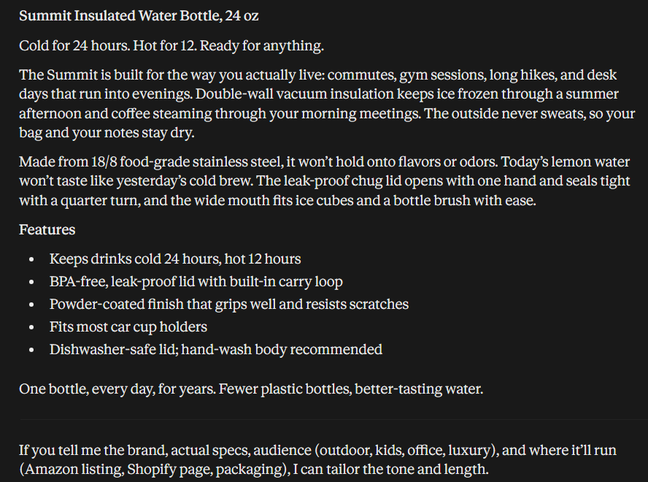
With no prompting at all, this review seems like it is targeted towards your average person, just your average person scrolling reviews on amazon or something similar. The response just seems bland, generic features like “dishwasher safe” and “leak proof”, every water bottle says that and it’s missing a price for this water bottle.

Part 2:
Prompt Given: Write a product description for a water bottle as if I am a product engineer trying to understand how it works, must include the price of materials to make things work, but keep it brief and to the point.
(role prompting technique: said I am a product engineer)
(constraint technique: added the part of must include prices of materials and keep it brief)
Response:
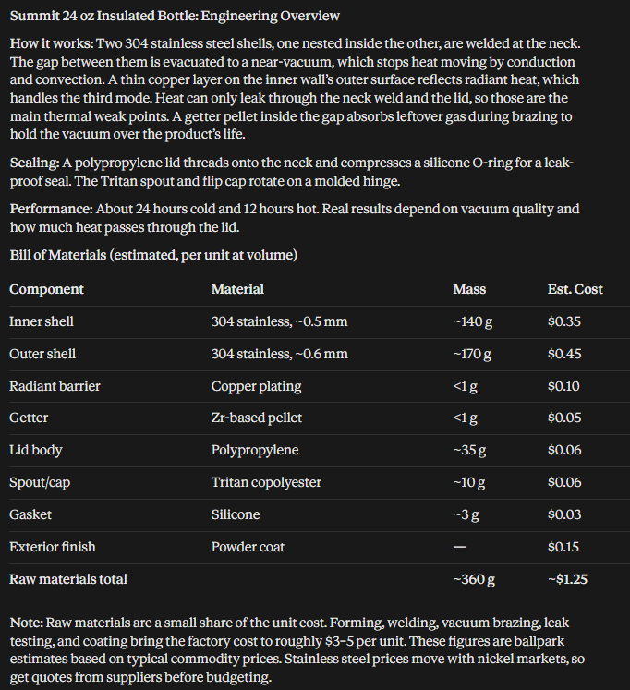
This response is definitely more geared towards a product designer like I asked, the role prompting technique worked, it uses engineering terminology that I would most likely understand if I was an engineer. The constraint technique worked to some degree, I should've been more specific but it kept the description to about a paragraph and when including the prices like I asked it kept the response to a concise table.

Prompt Given: Write a product description for a water bottle, this is for a professional reviewer who has a large audience and could generate a lot of revenue for us, this will be posted on a website. This response should be posted with a header for what is being reviewed and give me a table of positive features and a rating for each feature
(context technique: saying this is for a professional reviewer with a large audience)
(output technique: saying the table with the ratings)
Response:
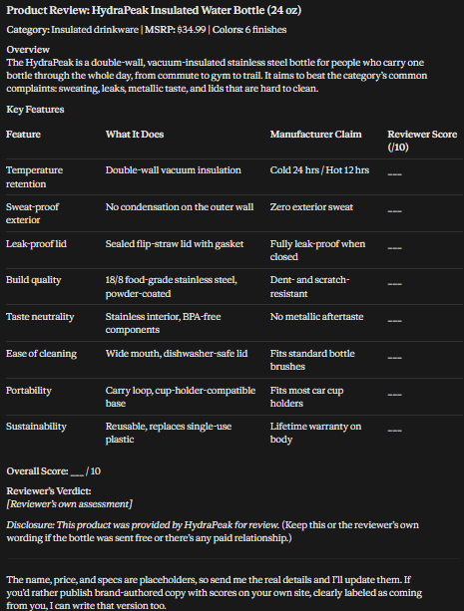
So again I should have been more specific saying that Claude is the reviewer so it filled in the ratings and missing information, however it followed the output format of giving me a table with ratings for each feature. It also gave a small review for a reviewer to write for the water bottle, which I didn’t specifically ask for, but it tried to follow the idea of this was for a professional product reviewer.

Prompt given: Write a product description for a water bottle, I want it to be a comedic response, here are some funny examples I found:
amazon product reviews
(used few-shot technique) (the link has several reviews on it)
Response:
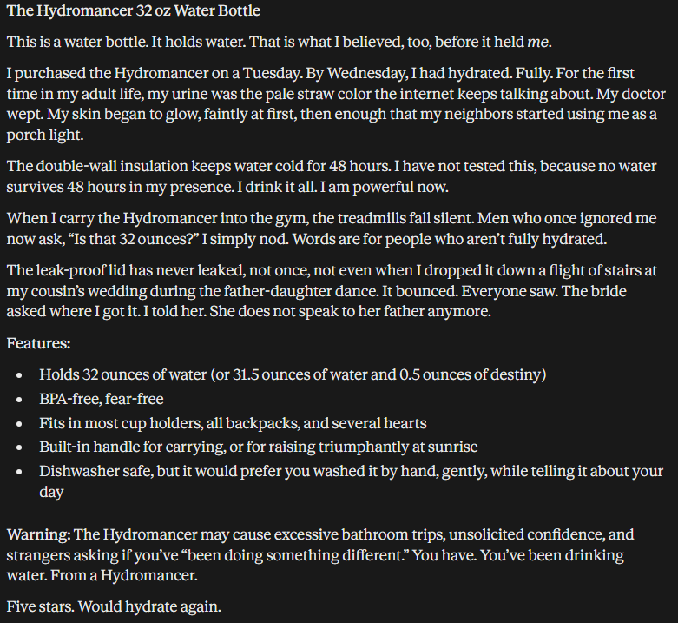
This review did what I wanted, it tried to be funny, it felt more personable, adding comedic aspects to it, like a warning about having to use the bathroom a lot and dropping the bottle down a flight of stairs. Compared to the original response, it is obvious it used the reviews from the amazon link to format this response better.

Part 3:

Item: Noise-canceling headphones
Prompt: Explain how noise-canceling headphones work.
Response:
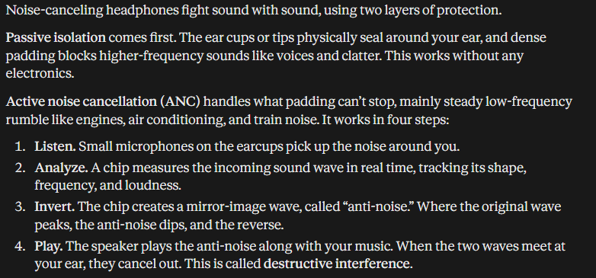
New prompt: Explain how noise-canceling headphones work, as if I am a child who doesn't know anything, keep it brief about a paragraph. Use bullet points for features / steps.
(role prompting technique: I am a child who doesn’t know anything)
(constraint technique: keep the length to about a paragraph)
(output format technique: told it use bullets for features / steps)
Response: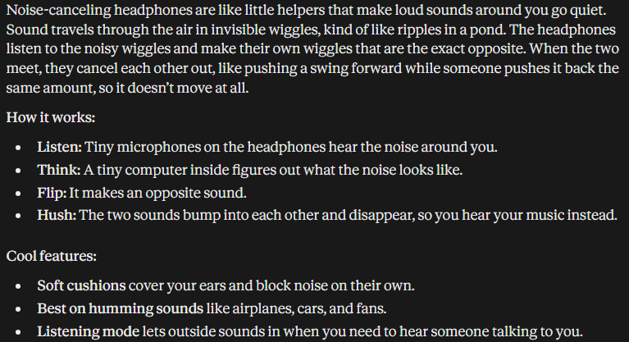
Claude's response after I used the techniques I mentioned, was formatted exactly how I wanted, it simplified the response that would be easy for a kid to understand. It used bullets specifically for the steps of how the headphones work and features they have. Lastly the response is 4 sentences and a couple bullets, which is just about the length of a normal paragraph.

Item: Ergonomic office chair
Prompt: What is an ergonomic office chair for?
Response:
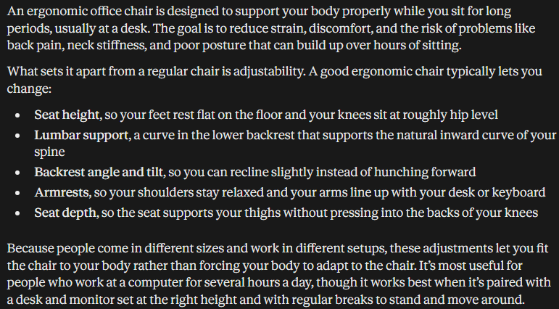
New prompt: I am a remote programmer, I sit all day and need a new chair, what is an ergonomic office chair, sell it to me I am looking for a new chair and want the best of the best, keep this to the point, don't fill the response with fluff.
(role prompting technique: I am a developer who sits all day)
(context: I want to buy a chair, sell one to me)
(constraint: keep the response brief and to the point
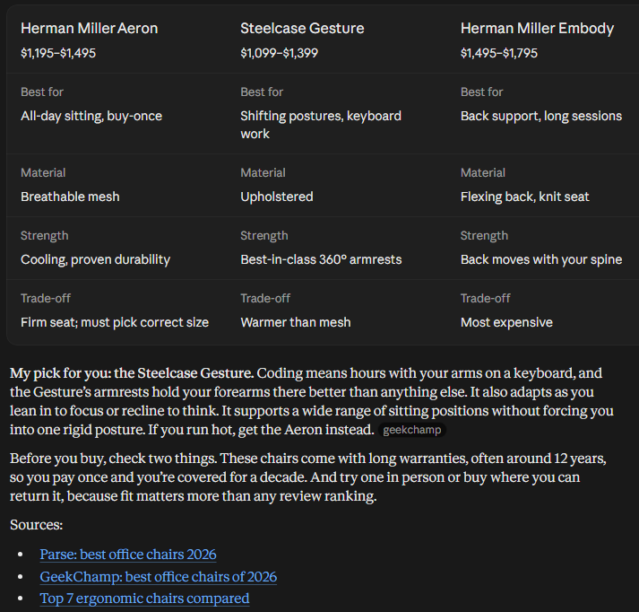
Response:
Since I specifically said I sit coding all day, it gave me a response / review about this chair for not just posture and back support but how it can help with arm rests since I am using them all day. I said I wanted to buy one, so it gave me not only one it picked but also links to other chairs, which was more than I expected Claude to do. Compared to the first response, this is significantly better and targeted towards me.

Overall I think role prompting makes the biggest difference, that or few-shot(but I didn’t use it much). However looking at just the responses given here, giving a role in the prompt helped Claude target the audience of the response better, it was able to target specific talking points based on who I need the response for.

